**Software Design Document**

**1. Introduction**

**The app is designed to help users effectively manage their time by providing personalized activity recommendations, fostering meaningful engagements, and enhancing life quality. The primary audience includes urban residents aged 18-45, encompassing students, professionals, and families.**

**2. Requirements Specification**

**User Requirements:**

**Users need a platform to explore personalized, meaningful activities based on their preferences.**

**Functional Requirements:**

**User registration and login functionality.**

**Personalized activity recommendations based on user preferences.**

**User-generated content for sharing activity ideas.**

**Social features such as commenting and sharing.**

**3. Overall Design**

**The app uses a modular architecture, with distinct components for user authentication, recommendation engine, content management, and social interaction. Key modules include:**

**Authentication Module: Handles user registration and login.**

**Recommendation Engine: Matches users with suitable activities using a tagging system.**

**Content Management: Allows users to create and share activities.**

**Social Interaction Module: Facilitates communication and engagement.**

**4. User Interface Design**

**The app features a clean and intuitive interface. Key screens include:**

**Login Screen: Prompts users to log in or register.**

**Home Screen: Displays recommended activities.**

**Activity Details Screen: Provides detailed information about a selected activity.**

**5. Key Technologies**

**Frontend: Developed using Kotlin and Android Studio for native mobile app functionality.**

**6. Testing and User Experience Analysis**

**Testing was conducted on a third-party cloud platform, simulating real-world usage. Results showed:**

**Performance: The app handled concurrent users efficiently.**

**User Feedback: Positive remarks on the ease of use but suggestions to enhance activity diversity.**

**Areas for Improvement: Include more interactive features and improve UI responsiveness.**

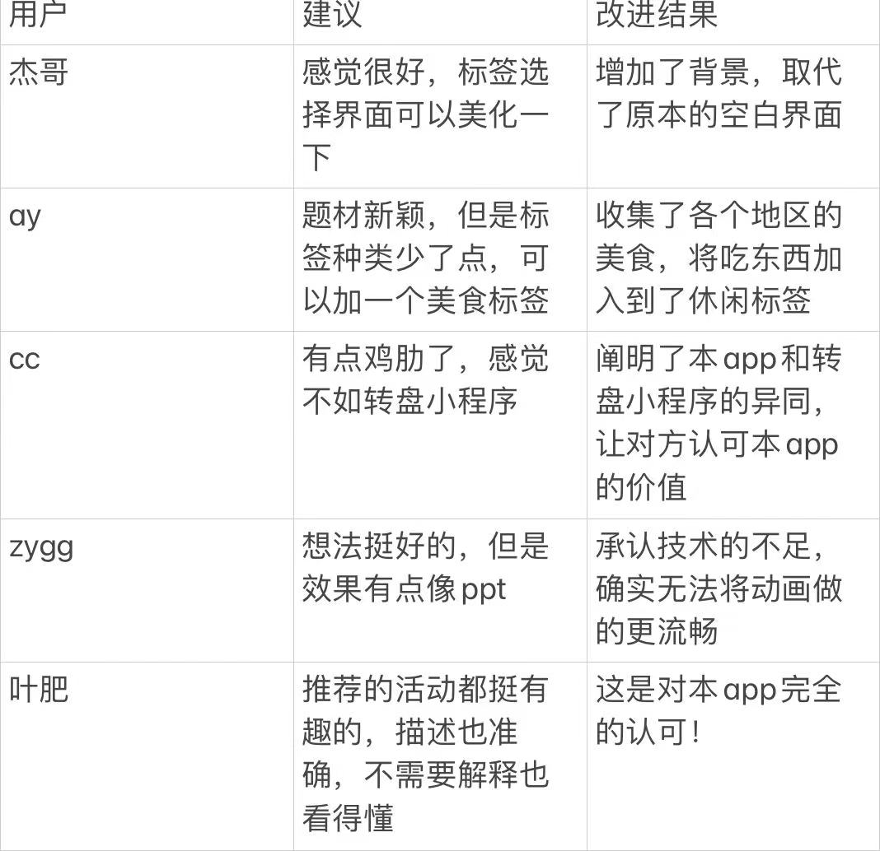

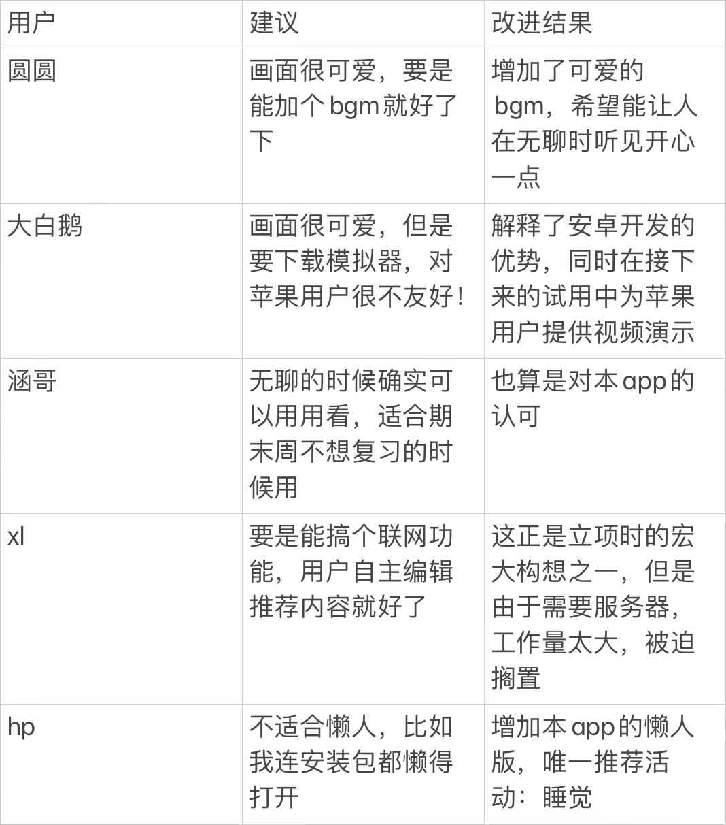

**7. Conclusion**

**The app successfully provides a platform for personalized activity recommendations and social interaction. Achievements include a functional recommendation engine and positive user feedback. Challenges included optimizing algorithms and ensuring scalability. Future improvements will focus on activity diversity, enhancing social features, and improving user retention.**